OVERVIEW
The Town of Lansing has contracted with a consultant team from Colliers Engineering & Design and Sustainable Planning & Design to assist with updates to the Town’s Zoning Code. The existing Zoning Code will be updated to reflect the vision, goals, and values of Lansing, incorporate smart growth land use practices, and align with recent initiatives such as the 2018 Comprehensive Plan, 2023 Agricultural Zoning District, 2024 Open Space Conservation Plan, and the 2025 Comprehensive Plan and Zoning Gap Analysis. Recommendations include:
- Agriculture & Natural Resources: Protect and strengthen farming as a cornerstone of Lansing's economy while preserving prime farmland, open space, scenic resources, and the health of Cayuga Lake through environmental stewardship and responsible zoning.
- Infrastructure, Transportation & Land Use: Expand municipal services, improve road safety, and shape a balanced built environment that directs growth to appropriate areas, respects Lansing's unique character, and fosters cooperative planning with neighboring municipalities.
- Economic Development & Tourism: Diversify and strengthen the local economy by supporting business growth, leveraging regional partnerships, and growing tourism through agritourism, cultural events, trail networks, and lakefront recreation.
- Housing, Neighborhoods & Community Character: Create compact, mixed-use neighborhoods with walkable streets, provide diverse and affordable housing options for all residents, and preserve the historic character of Lansing's hamlets and green spaces.
- Sustainability & Resilience: Reduce greenhouse gas emissions, promote renewable energy across residential and municipal operations, and build community resilience against climate-related events through proactive infrastructure planning.
- Recreation & Cultural Resources: Expand parks, trails, and recreational programming, preserve historic structures and hamlet character, and foster community identity through cultural events and public spaces.
The purpose of this effort is to simplify, modernize, and streamline the Town of Lansing’s Zoning Code, while codifying the policies and recommendations from recent planning efforts and incorporating development best practices through smart growth. The revised land use regulations will ensure that new development and redevelopment opportunities occur in a sustainable manner that supports both the environmental and economic well-being of the Town.
NOTE: This project is partially funded through a NYS Department of State (DOS) Environmental Protection Fund Smart Growth Community Planning and Zoning Program grant.
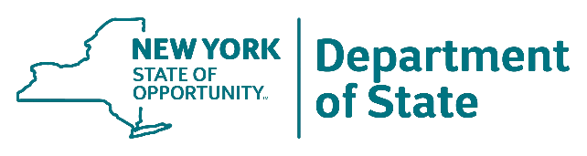

WHY UPDATE THE ZONING CODE?
There are many reasons to update our zoning regulations, but primary considerations include efforts to:
Align with the Town Comprehensive Plan and Other Relevant Plans and Studies
Per NYS Town Law §272-a, a town’s land use regulations must be in accordance with its adopted comprehensive plan. As part of this zoning code update effort, the Town of Lansing will be addressing the gaps in the zoning code as identified in the 2025 Zoning Gap Analysis memo, as well as assessing the needs and recommendations of the other relevant plans and studies such as:
- 2015 Town of Lansing Agriculture & Farmland Protection Plan
- 2021 Town of Lansing Natural Resources Inventory
- 2022 Town of Lansing Parks and Recreation Plan
- 2024 Town of Lansing Open Space Conservation Plan
Better Direct Future Community Investment
Municipal zoning laws determine the types and locations of allowable land uses, guide the design of structures and sites, and define a community’s character. Municipal zoning laws also activate the land use recommendations established in community planning initiatives. When zoning codes are out of sync with community goals, it can have a detrimental effect. This often results in undesirable development patterns, unnecessary barriers to investment, and inefficient or burdensome administrative procedures. The implementation of Smart Growth principles through zoning also helps to address local economic, environmental, energy, and equity issues.
Modernize the Zoning Code
Because of shifts in the market and development needs, updates to the Town of Lansing Zoning Code and Zoning Map are necessary. Revisiting the Lansing’s Zoning Code will ensure that it is supportive of and responding to current community needs and investment opportunities. Additionally, the update will serve to make the Town’s Zoning Code easier to understand and implement, removing outdated, conflicting, and overcomplicated provisions. The Zoning Code will also be updated to follow a more user-friendly format.

PROJECT PROCESS & SCHEDULE
The Town of Lansing Zoning Code update will occur over an 18-month period. A Zoning Advisory Committee (ZAC) comprised of review board members, residents, and local stakeholders has been designated to oversee the process. The ZAC will meet with the consultant team six times over the project timeline. Additionally, multiple public input events will be held at various stages in the update process.
The schedule below identifies the general timing of key milestones and meetings for the Zoning Update Process:

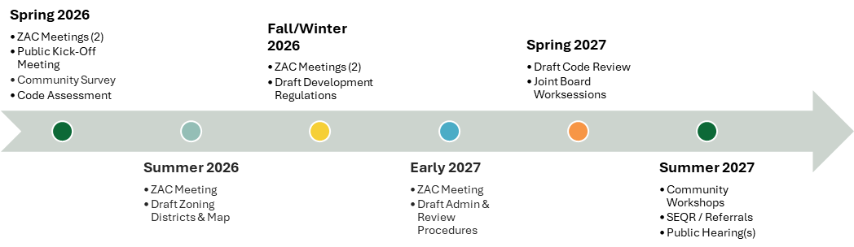

PUBLIC ENGAGEMENT UPDATES
To help guide the Zoning Code revisions, the Town will be seeking public input at various points in the process. Check back here as the project progresses for updates on past and forthcoming public events and surveys!
Public Kick-Off Meeting – March 25
Community Survey - TBD

WHAT IS SMART GROWTH?
Generally, “smart growth” is a considered a sound approach to land use planning and development that incorporates best practices for community sustainability and stability. Further described by the NYS Smart Growth Program, smart growth supports and integrates four key themes: Equity, Economy, Environment and Energy/Climate.
- Equity—Smart Growth champions inclusivity, equity and diversity by encouraging a variety of housing types and employment opportunities for people of all incomes, backgrounds, ages, and abilities.
- Economy—Smart Growth enhances community quality of life, creates livable, sustainable communities and revitalizes downtowns, which is proven to help attract and retain businesses and workers.
- Environment—Environmental stewardship is woven into the fabric of Smart Growth, with green spaces, natural resources, and parks seamlessly integrated into community design.
- Energy/Climate—Smart Growth promotes walkable, bikeable, transit-accessible neighborhoods with a compact mix of land uses, which minimizes reliance on cars and thus reduces energy use and greenhouse gas emissions. Smart Growth also encourages clean energy and climate resiliency.
To achieve long term development success, several key principles will be considered as part of this Zoning Code update. It is important to note that the application of these principles will be considered in the context of what is appropriate for the Town of Lansing, as there is no “one size fits all” for land use regulation. These Smart Growth principles include, but are not limited to:
- Promoting a mix of land uses in development focus areas.
- Enabling a diverse mix of housing types, providing opportunity and choice for all.
- Prioritizing infill and redevelopment of existing buildings to revitalize neighborhoods and downtowns.
- Providing well-planned, equitable, and accessible public spaces.
- Encouraging compact neighborhood design and concentrated development around existing infrastructure.
- Preserving open space, parks, and natural resources.
- Increasing mobility and circulation by supporting alternative transportation options, such as walking, biking, and transit.
- Increasing climate resiliency and adaptation and reducing greenhouse gas emissions, through nature-based solutions, clean energy resources, and green infrastructure.
- Building on traits that make a distinctive and attractive community with a strong sense of place.
- Engaging in an inclusive, collaborative public planning process that considers the needs and character of the community.

